

VILNIUS UNIVERSITY
SIAULIAI ACADEMY
BACHELOR PROGRAMME SOFTWARE ENGINEERING

SYSTEM APPLICATIONS AND PRODUCTS IN DATA PROCESSING (SAP)

E-service Design Principles and Infrastructure Solutions. Practical Work № 6

Student :
Lecturer: Prof. Dr. Dale Dzemydiene

Siauliai, 2023

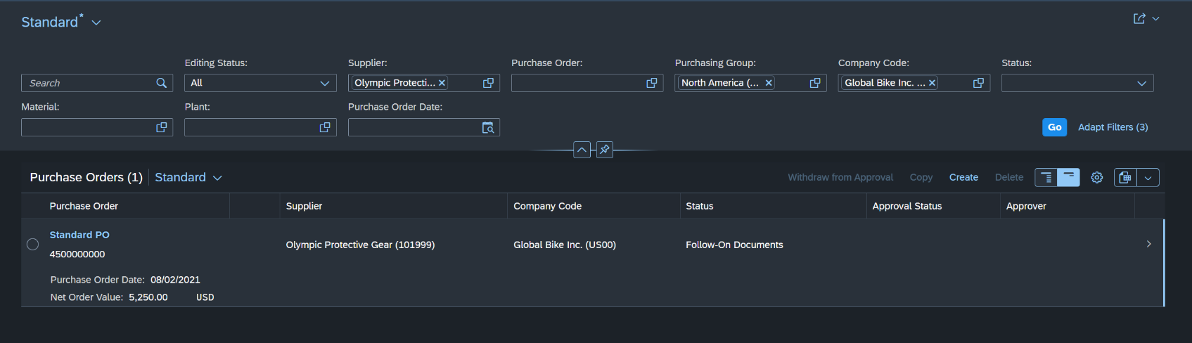
MM 1: Display Purchase Order
Task: Display a purchase order for 60 off road helmets and 150 road helmets from the vendor, Olympic Protective Gear. The purchasing group North America (N00) created this purchase order for the purchasing organization GB US (US00).

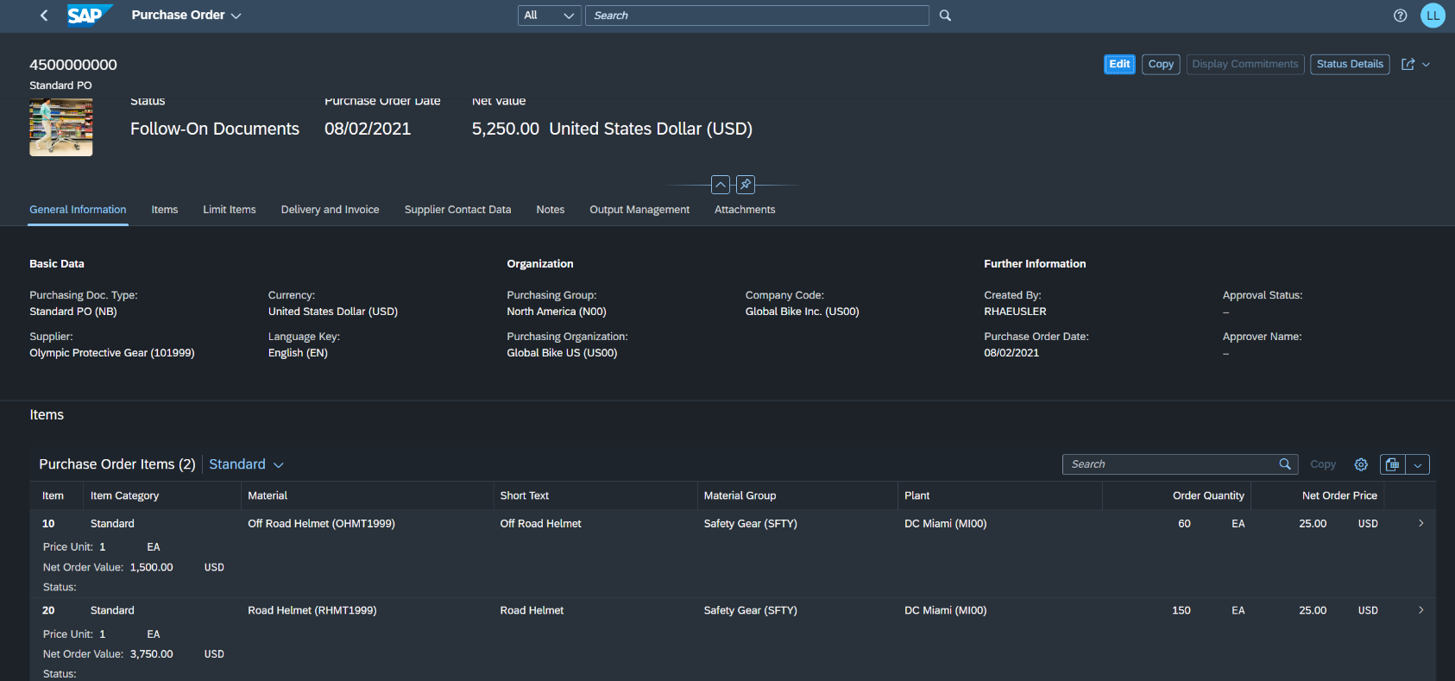
Pic 1. Through Manage Purchase Orders app we found the result for our values.

Pic 2. More details about the purchase order

MM 2: Display Goods Receipt for Purchase Order
Task: After the ordered goods have arrived from the supplier, the goods receipt into the warehouse is posted manually in the system by the warehouse receipt accountant. This records that the ordered products have arrived within the required time period and under the specified quality conditions. Display the goods receipt for the purchase order from Task 1.

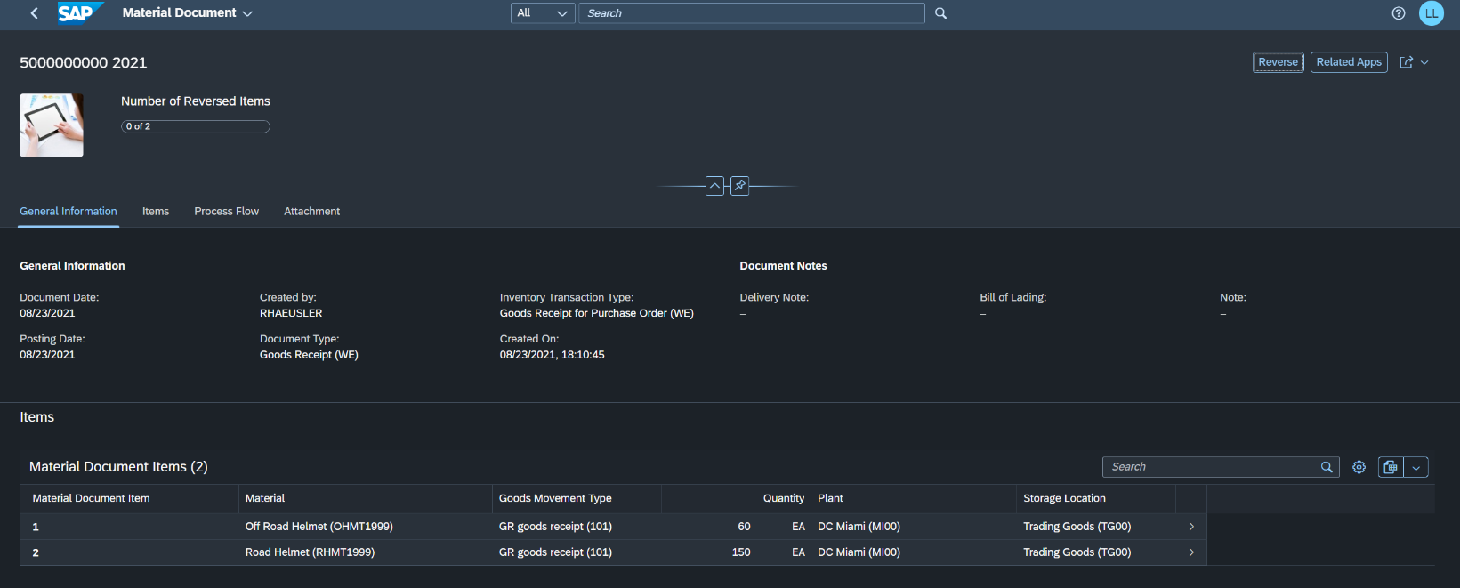
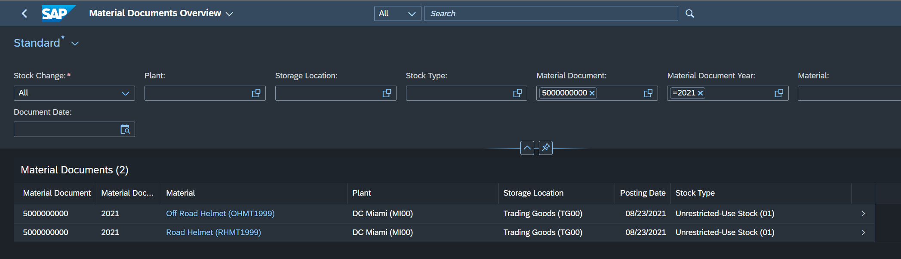
Pic 3. Material Documents Overview with all results for given values.

Pic 4. More details, for example about booking date and the process flow.

MM 3: Display Invoice Overview from the Vendor
Task: In the meantime, an invoice for 5,250.00 USD has been received from the supplier Olympic Protective Gear for the delivered goods. This was entered manually in the system. The invoice is posted to an existing expense account in the general ledger and creates an open item in Accounts Payable. The invoice will be cleared at a later time point by issuing a check to Olympic Protective Gear. View the invoice entered in the system.

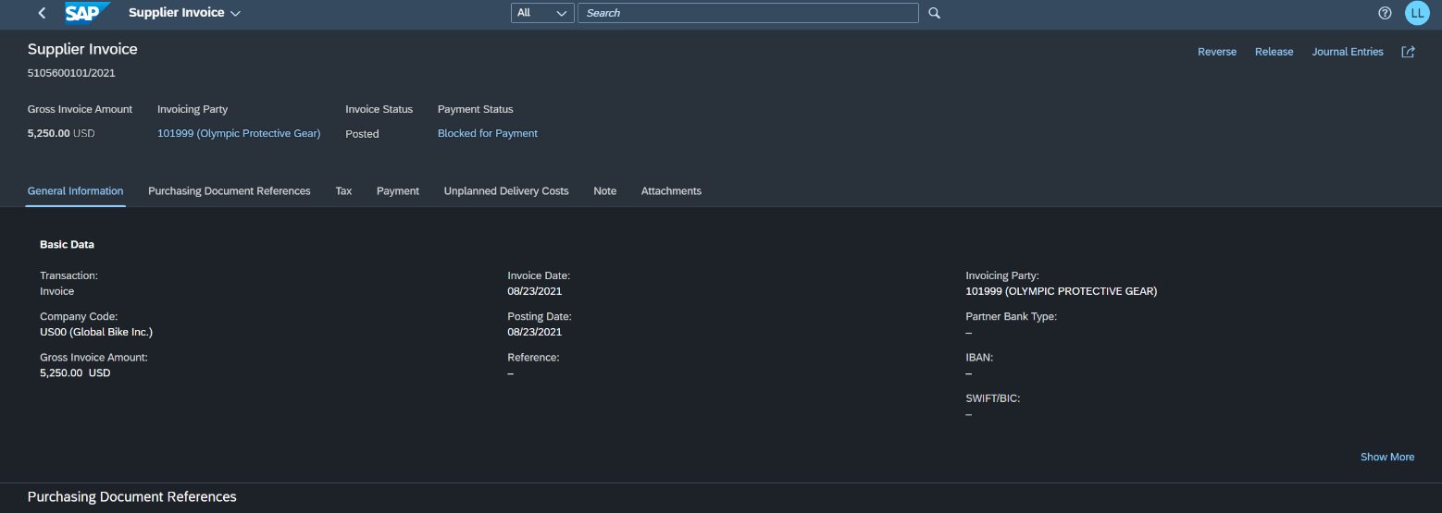
Pic 5. Supplier Invoices List overview

Pic 6. Supplier invoice
As you can see in the document, the invoice document shows the total amount and the individual amounts for the two invoice line items in USD.

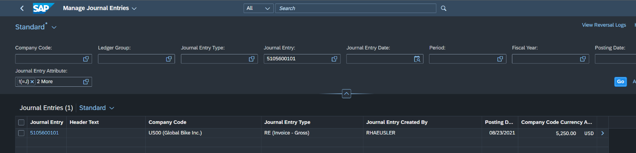
MM 4: Display Payment to Vendor
Task: After the invoice has been entered in the system, it can be paid by the payment officer. This clears the vendor account debited by the invoice receipt. Since the invoice in this example is paid by bank check, this will debit the bank check account in the general ledger (with the same value) at the same time.

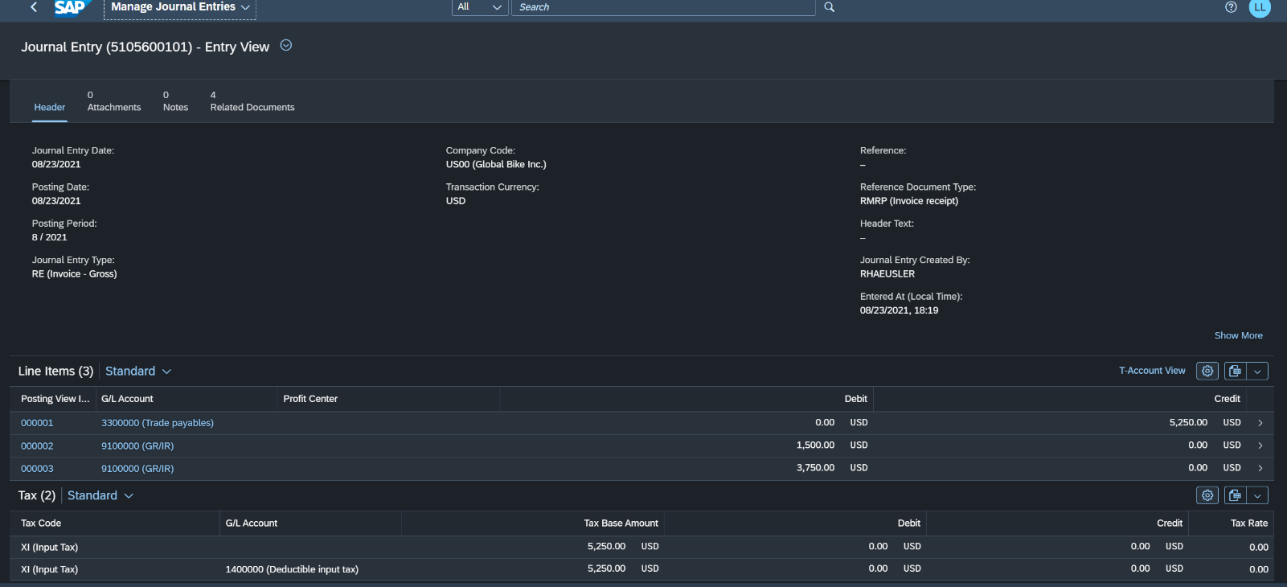
Pic 7. The corresponding journal entry is displayed.

Pic 8. Value flows on the G/L accounts concerned is displayed.
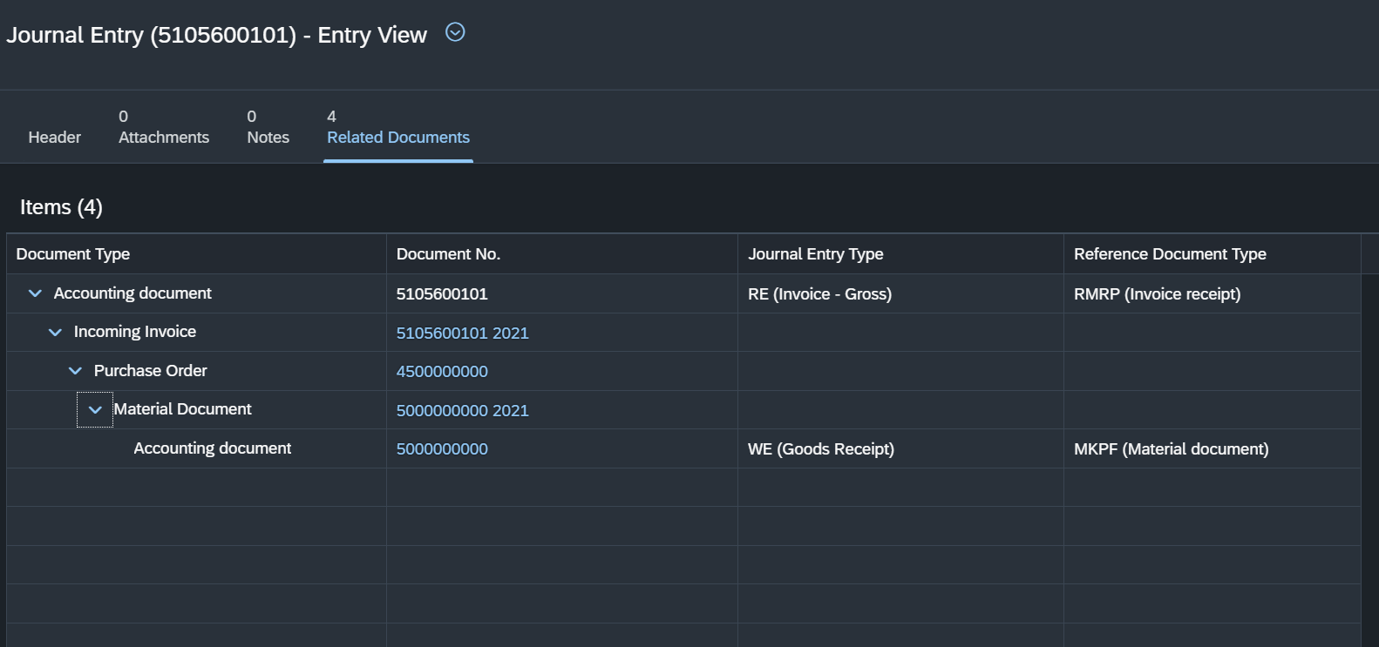
Pic 9. Related Documents tab

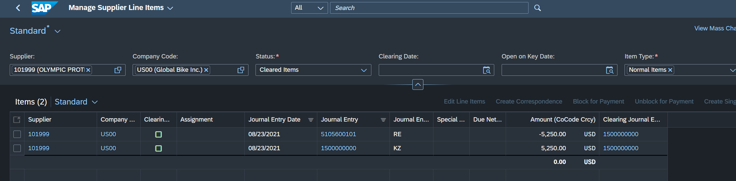
MM 5: Display Supplier Line Items
Task: Display all activities and the corresponding balance of the supplier Olympic Protective Gear. You should see one credit posting and one debit posting representing the invoice receipt and the payment posting to Olympic Protective Gear for balance clearing, respectively.

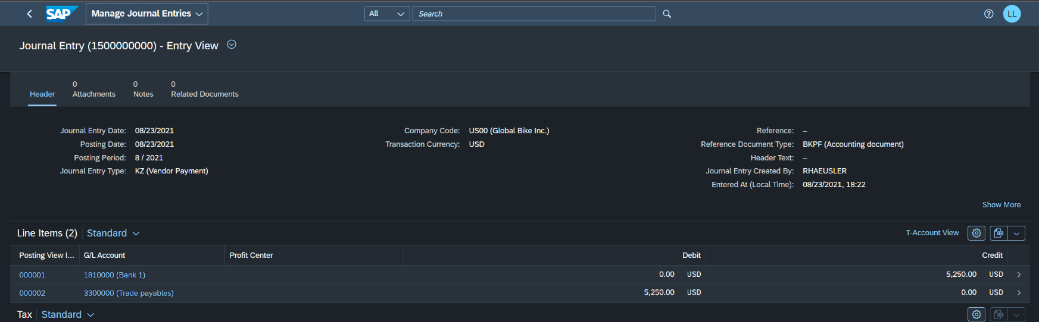
Pic 10. Overview of the journal entry and journal entry type of the individual items.

Pic 11. Clearing entry view.

